  - ENEMLOS NEWSLETTER Issue 4/2021
October/November/December 2021
 |  | LEGAL CLINICS IN SERVICE OF VULNERABLE GROUPS: ENHANCING THE EMPLOYABILITY OF LAW STUDENTS THROUGH PRACTICAL EDUCATION
facult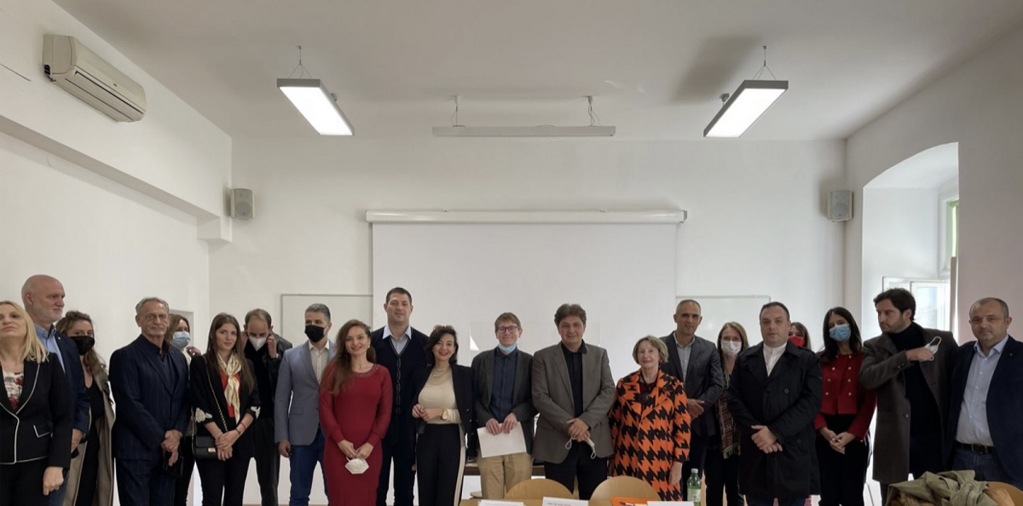

IN THIS ISSUE

STUDY VISIT TO THE FACULTY OF LAW IN ZAGREB & regents university ONLINE WORKSHOP
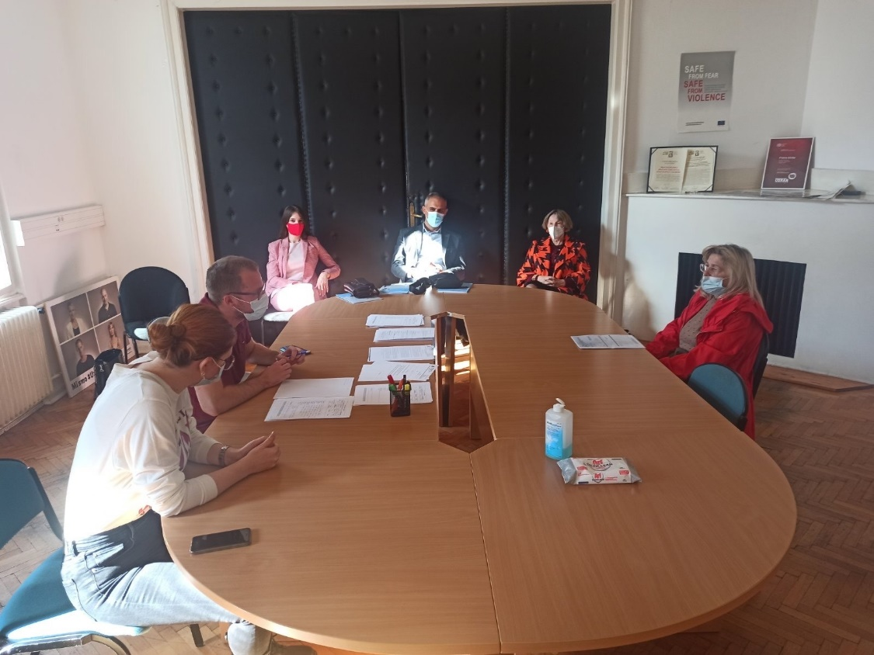  At the Legal Clinic in Zagreb |  | A delegation of teachers from the Faculty of Law of the University of Montenegro and representatives of non-academic partners in the ENEMLOS project visited the Faculty of Law University of Zagreb, in the period from 19 to 23 October 2021

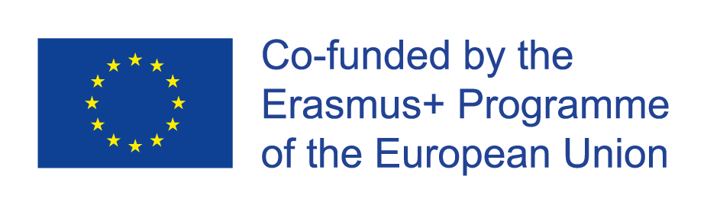

The Project Management Team Meeting on 20th October 2021
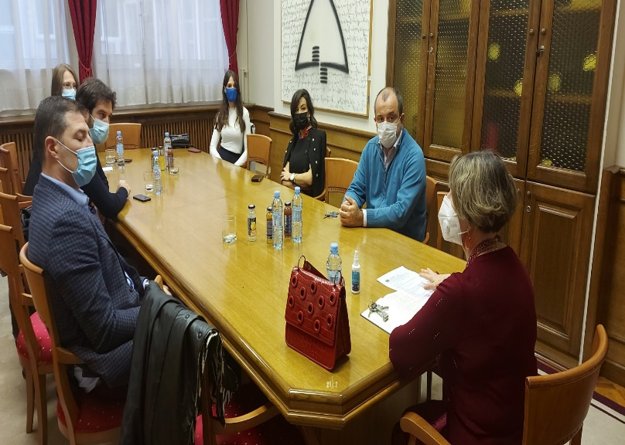
The Project Management Team Meeting on 22nd November 2021

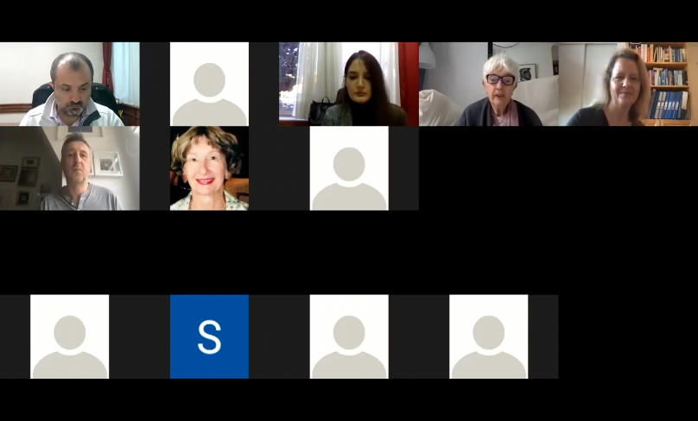
The workshop held by representatives of the Regents University of London via ZOOM, on November 29, November 30 and December 1, 2021

